James C. Rogers Jr.
tejaslandman@aol.com
www.jamescrogersjr.com
210-845-8274
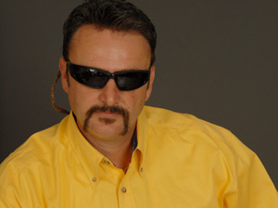
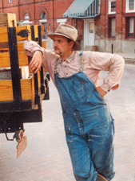
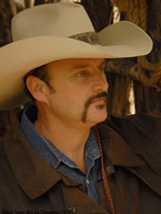
Height: 6’2”
Weight: 220
Eyes: Blue
Hair: Brown

FILM EXPERIENCE:
Bass Reeves Marshal James Fagan - Starring Role Ponderous Productions
Second to Last Worst Day of My Life Hit Man - Starring Role Ponderous Productions
Die When Your Done Sheriff Independent Film
Two Mothers for Zachary Salesman Sporting Store Halmark, RHI, Avenue Pictures Prods
Stars Fell on Henrietta Farm Hand MalPaso, Warner Bros. Pictures
Against the wind Cowboy #1 Ponderous Productions
Going No where Fast Dancer
Innocence Saga Mercenary Ponderous Productions
Friday Night lights Dancing Instructor/Dancer
Apocrypha Future Texas Ranger Ponderous Productions
Le Tour Rider (The Cyclist) Sammy Samson/Lead Owner Sammy Samson Subs
End of the Innocence CIA Agent # 1 Ponderous Productions
Temple Grandin Ranch Hand HBO
Jim Gaffigan Singing Cowboy Comedy Central
Lovers of Hate Bryan Poyser
Serial Rabbit 3 Splitting Hares Texas Ranger Ponderous Productions
Donato Red-Neck Bar-Tender/Lead Mary de los Santos Harder
Green Texas Ranger Ponderous Productions
OK The Gambler Ponderous Productions
Giant Salvinia Fisherman Texas Parks & Wildlife

Page 1 of 2
COMMERCIALS:
Intenmann’s Bakery (Bonnie and Clyde) Texas Ranger / VO UK Production

TRAINING
Improv, Asaf Ronen (Class Taken Twice)
Intensive On-Camera Acting Workshops, Toni Cibb Brock & Sally Allen
Actors Audition Class, Calliope San Antonio, Texas
Acting for Film, Gabriel Folse, Austin, Texas (Class Taken Twice)
Creativity, Acting for Film, Babes George, Paramount, Austin, Texas
Auditioning techniques for film and TV acting roles, Dean Reading, Texas State University
Drama, MB Smiley High School, Houston, Texas

SPECIAL TALENTS:
Horseman, Expert Marksman with Firearms, Historical Expert of Western Traditions, Top Ten Real Estate Salesman.

HOBBIES / SKILLS: Boxing, Waterskiing, Cooking on the Grill, Fishing, Farming, Professional Horseman, Firearms Marksman ,Bow and arrow, Ranching, Baseball, Football and Motorcycles.

Page 2 of 2

